**Name: Dhruv Barot**

**Student Id: 101415874**

**Course code: Comp3133**

**Lab Exercise 05**

**Screenshots**

**Screenshot 01:**

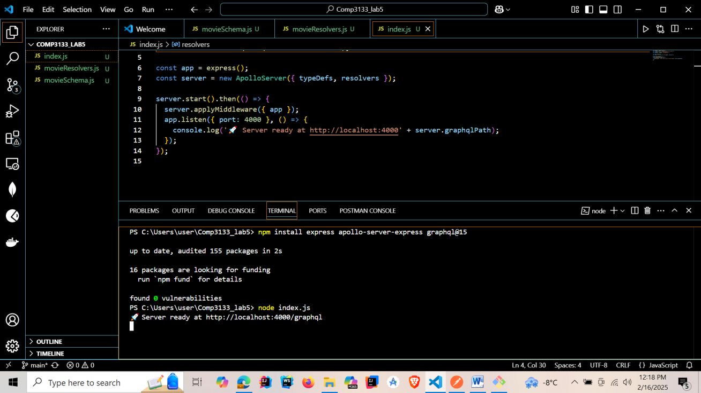

**Screenshot 02: Get All Movies**

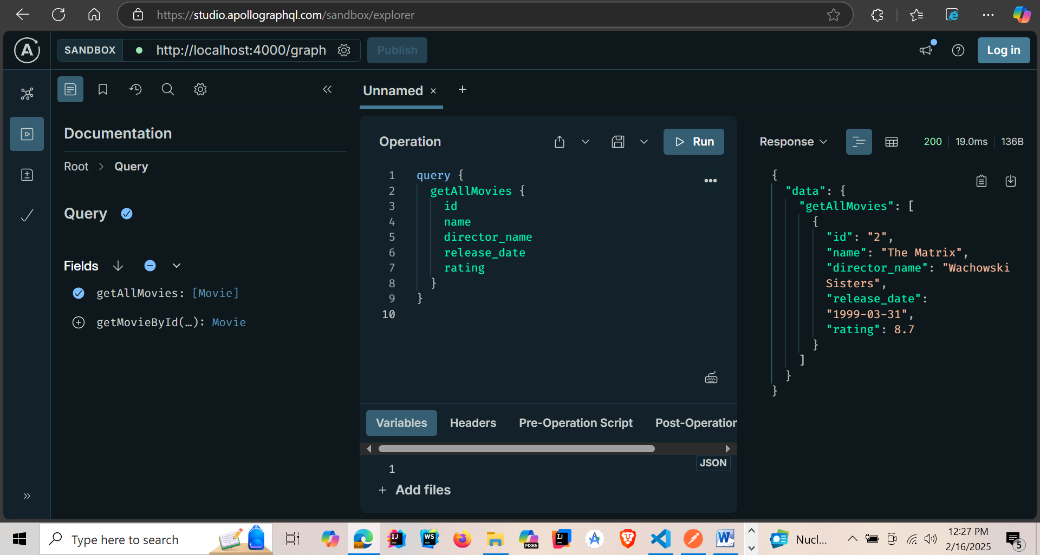

**Screenshot 03: Get Movie by ID**

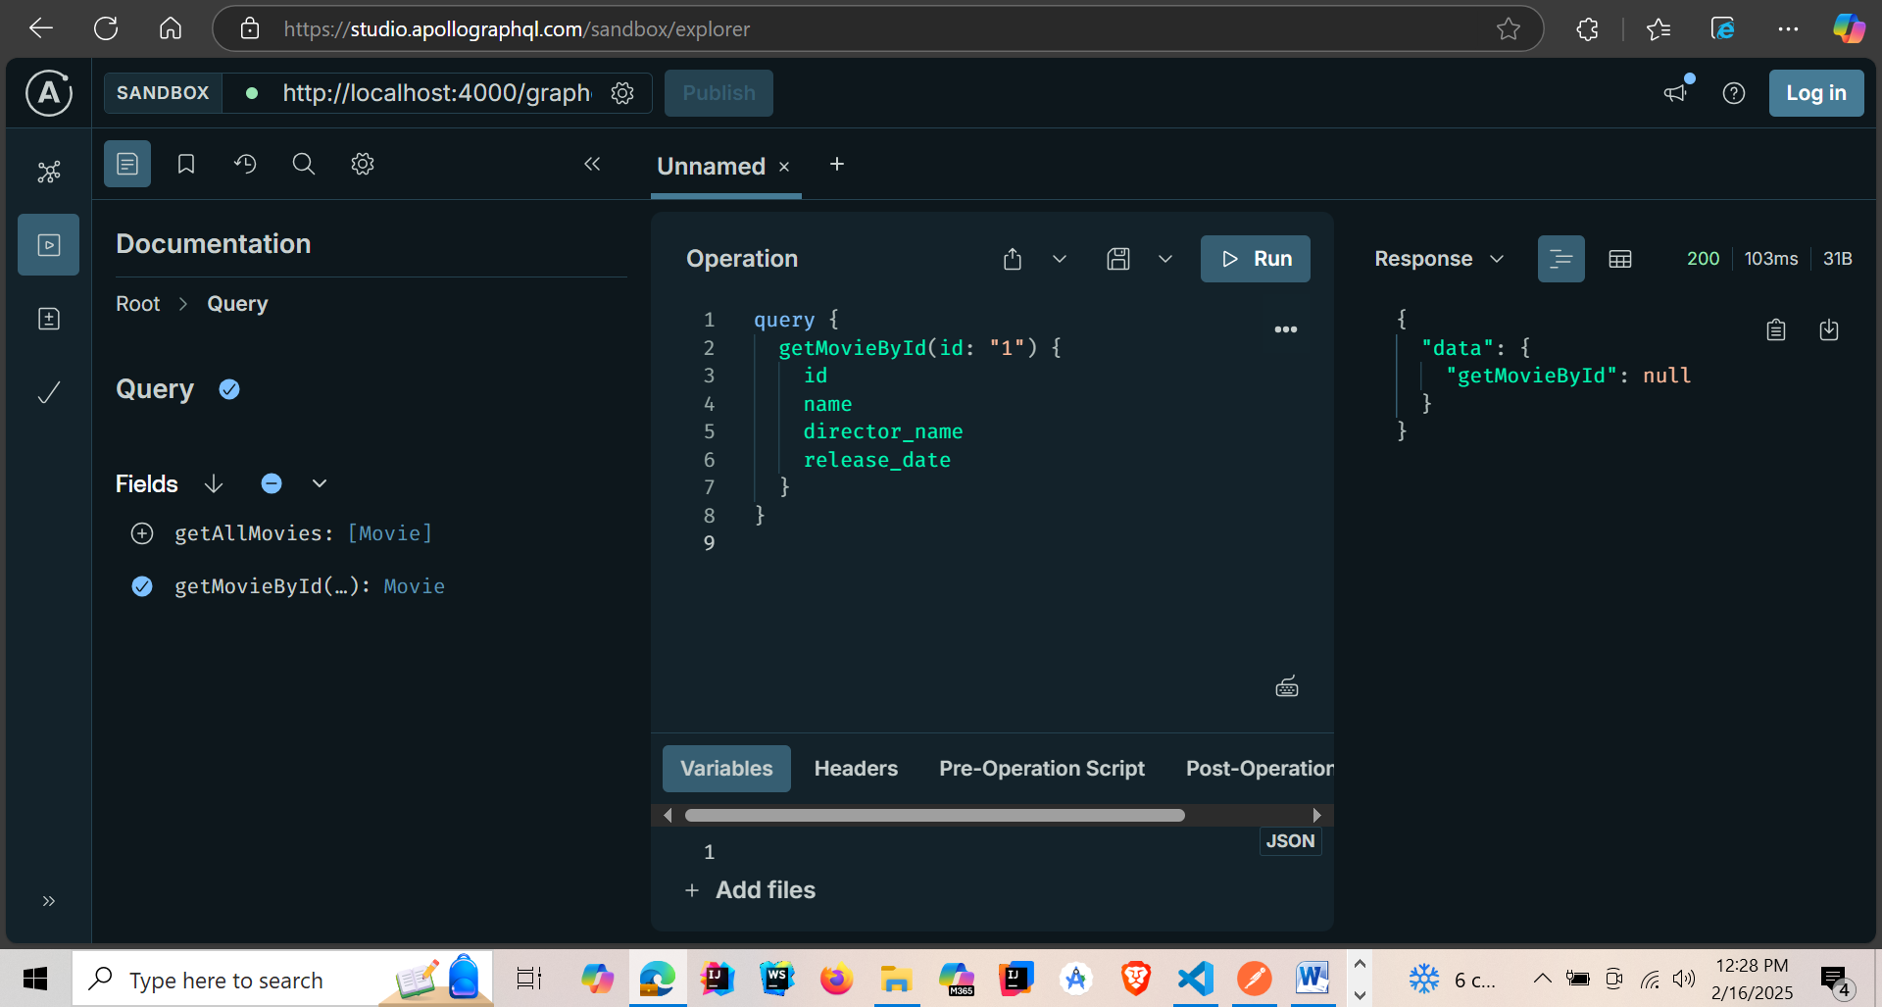

**Screenshot 04: Add a Movie**

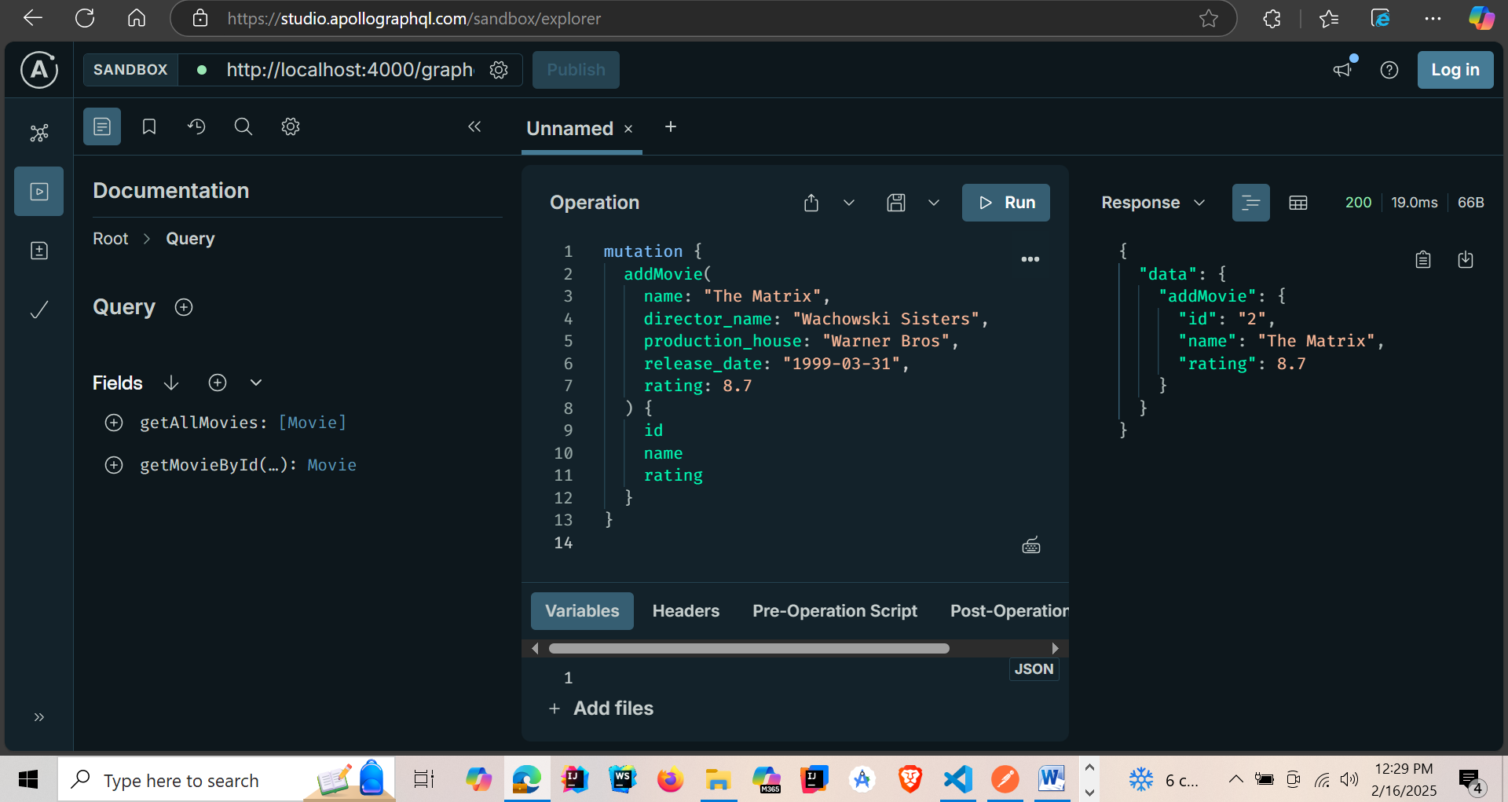

**Screenshot 05: Update a Movie**

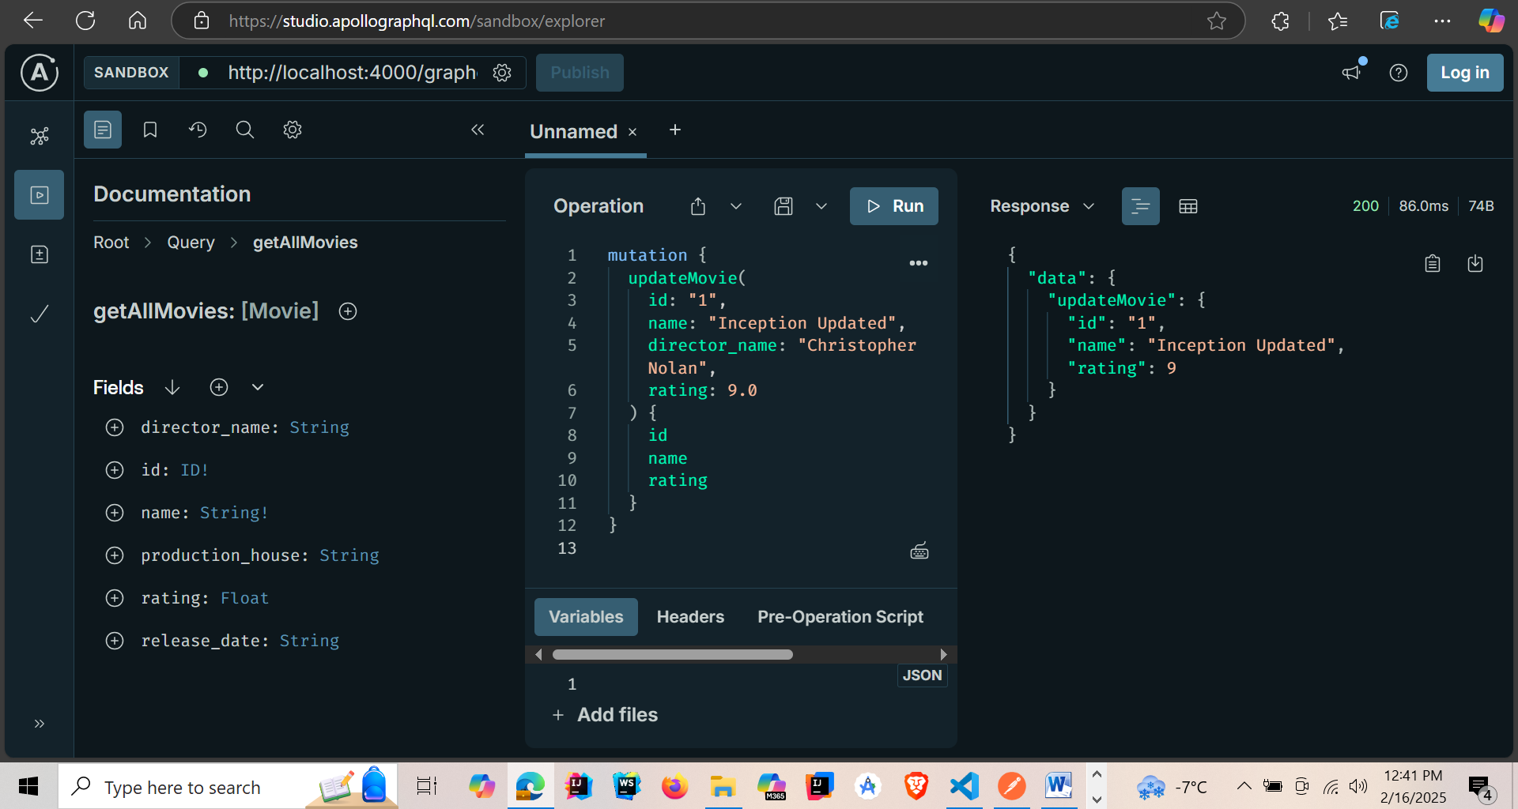

**Screenshot 06: Delete Movie**

